Planeshift Preview: Hull Breach
Aaron Forsythe
See what Brian Kibler thinks.
There was a conscious decision to not print Disenchant in Invasion, making the set the first standalone ever to forego that particular staple.
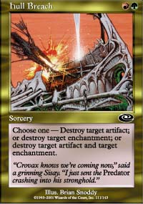
In its place, we have been given several new options for dealing with enchantments and artifacts, from Disenchant's body-double - Dismantling Blow, to the Mutation twins - Aura and Artifact. Each offers the caster a different benefit over Disenchant, such as card drawing or token generation, at a cost of extra mana or a limitation of legal targets.
Planeshift throws another such card into the fray - Hull Breach. A sorcery with a casting cost of RG, Hull Breach's text box boils down to "destroy target artifact and/or enchantment."
In Limited play, the Breach will probably see a little less play than Dismantling Blow - maindecked when no other cards are playable, and sided in often against a whole range of targets, both artifacts and enchantments alike.
To measure the card's effectiveness in Constructed (mainly Standard) play, we have to look at both what it is capable of and what it is competing with.
The card's benefit over Disenchant is that it can hit two targets - both an artifact and an enchantment - at the same time. The bad news that comes along with that is there are very few popular Standard decks running more than four artifacts and/or more than eight enchantments, meaning you won't consistently be netting devastating two-for-ones with this spell. Here's a look at the "best" decks right now and what they're likely packing:
Rebels: 4 Parallax Waves, possibly Crusades, possibly Chimeric Idols
Blue/White Control: maybe no targets at all; possibly Millstone, Story Circle, Teferi's Moat, Tsabo's Web
Fires: 4 Chimeric Idols, 4 Fires of Yavimaya, 4 Saproling Burst
Ankh-Tide: 4 Ankh of Mishra, 4 Parallax Tide, possibly Tangle Wire
Blast-O-Geddon: 4 Tangle Wire, 4 Chimeric Idol, possibly Parallax Wave, possibly Saproling Burst
Blue Skies: some number of Rising Waters
MachineHead (R/B): 4 Chimeric Idols, 4 Seals of Fire (not exactly prime targets)
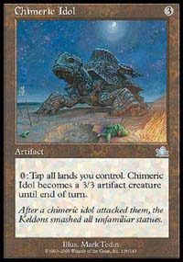
Unless one of these decks finds it necessary to play four or more Diamonds in addition to everything listed above, there should be no commonly used deck in Standard that sports at least eight artifacts AND eight enchantments. That means Hull Breach's two-for-one potential is going to have to be considered "gravy" - a nice possible side benefit - and not what the card is going to usually do in an average game. Of course, all this could change with Planeshift, especially if something shapes up to be another ubiquitous artifact along the lines of Chimeric Idol or Masticore.
So why would you play with it at all? The sorcery speed will surely be a deterrent - Saproling Burst will often get to attack for 12 before Hull Breach can destroy it. On a pure power level, Hull Breach loses to Disenchant for no reason other that casting speed.
Speed isn't everything. The real "power" of the Planeshift card can be found in the upper right-hand corner: the little tree and the little fireball. "Red" and "Green." Hull Breach is not white, which means red/green decks will no longer have to splash other colors if they are looking for cheap, targeted enchantment removal. Originally, the only real option for pinpoint artifact AND enchantment removal within red and green was Creeping Mold - a card marginally popular when Trinity Green decks were in full force, but now four mana is a little harder to come by. Hull Breach can do for RG what it takes Creeping Mold 2GG to accomplish, with the exception of destroying a land. That seems like a fair tradeoff.
In a deck like Fires, sideboarded green enchantment destruction was often of the sweeper variety, like Reverent Silence and Calming Verse. With Reverent Silence, the opponent often gained six life in a tight game, and destroying your own enchantments was always a concern. Calming Verse, while capable of not destroying your own cards as long as you tap out, always costs four mana. Hull Breach seems like a worthy replacement for both of those cards so long as super-enchantment decks (like last year's Parallax Replenish) don't become popular.
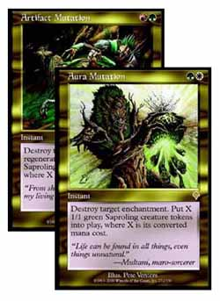
How does Hull Breach stack up against the Mutations? Aura Mutation generates a more powerful effect (Saproling generation) than Hull Breach does, but suffers from being white, as well as having a limitation on what it can target. Artifact Mutation may be costed the same as Hull Breach and an instant to boot, but it has yet to become a popular sideboard choice, mostly due to the lack of high-impact artifacts currently in the Standard environment.
So if you're playing a red/green deck and you are wanting for cheap artifact and enchantment removal for your sideboard, put away the Cities of Brass because you now have a solid in-color option with Hull Breach.
Hull Breach may be the best sideboard card since Sliced Bread (1GG, Enchantment, never mind...), but is it worthy of a main-deck slot in today's Standard? You're probably safer if you say no. Red/green decks like Fires have very little room for utility, as what might be an answer in one match ends up a dead card in another. When playing fast threat-based decks, each dead card you draw gives your opponent one more turn to stabilize.
Of course, Hull Breach will be Standard-legal for quite a while. Five new expansions plus Seventh Edition may provide enough juicy targets for the Breach that you'd be dumb not to maindeck two or three.
Until then, be content to have it at your disposal for games 2 and 3, side it in when necessary, and who knows? Maybe you'll get lucky and two-for-one somebody.
For information about Planeshift Prereleases, click here.

